ROBERT INDIANA

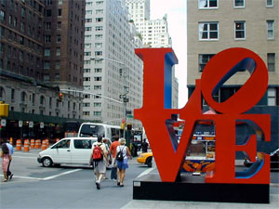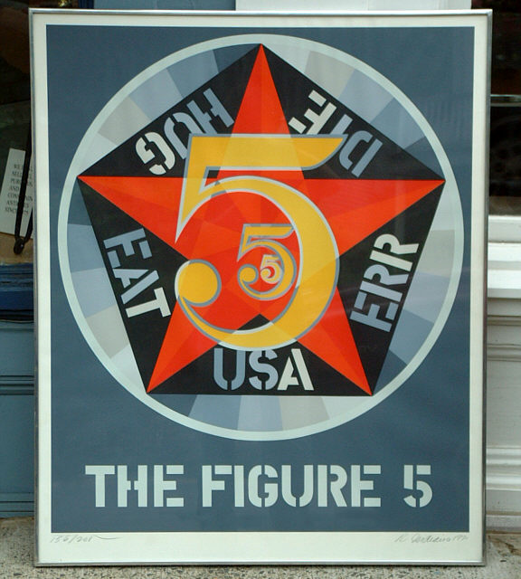
“LoveNYC” Rhythm/Pattern/Balance/Contrast “The Figure 5” Rhythm/Contrast/Balance

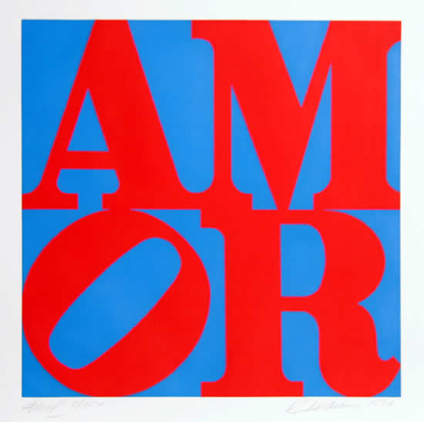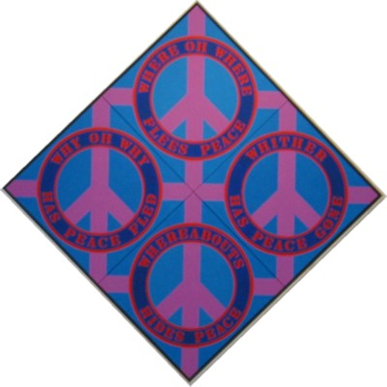
“Amor” Balance/Contrast “Four Diamond Peace Diamond” Balance/Rhythm

ROBERT INDIANA 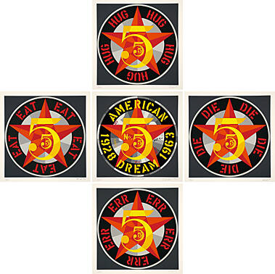
"American Dream # 5" (The Golden Five) Balance/Contrast/Unity/Rhythm/Pattern

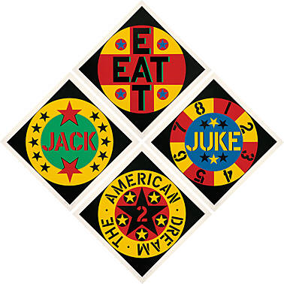
"The American Dream # 2" Balance/Contrast/Unity/Rhythm/Pattern
ROBERT INDIANA

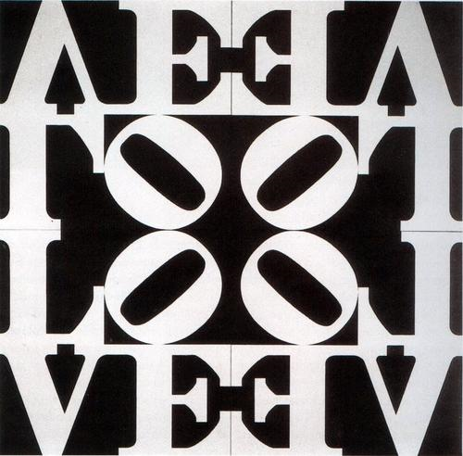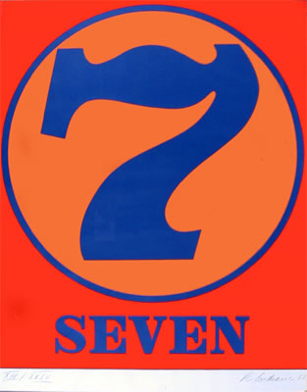
“Love Rising” Pattern/Balance/Contrast “Number 7” Balance/Contrast

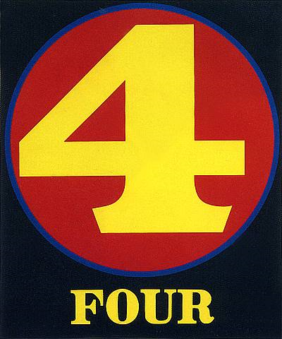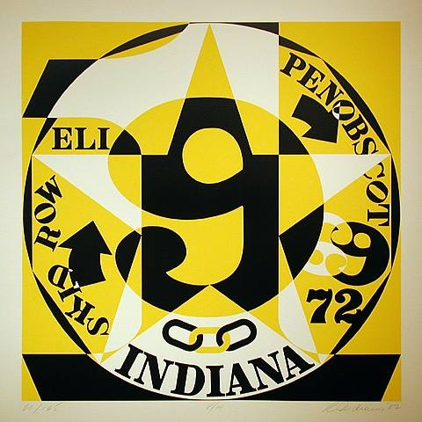
“Four” Balance/Contrast/Unity “Autoportrait” Contrast/Balance/Unity

ROBERT INDIANA
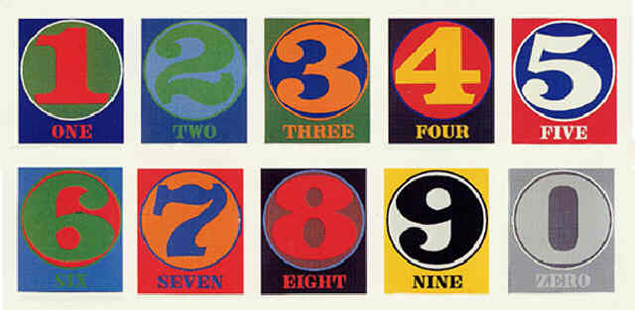
“Numbers” Rhythm/Contrast/Unity/Balance

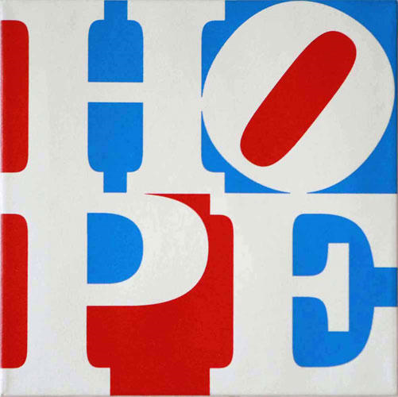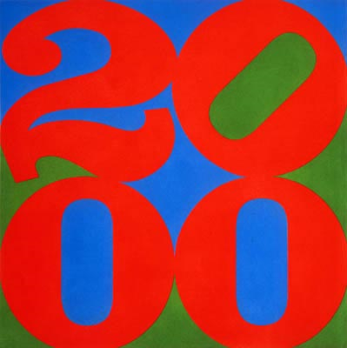
“Hope” Balance/Rhythm/Contrast/Unity “2000” Balance/Rhythm/Contrast/Unity

